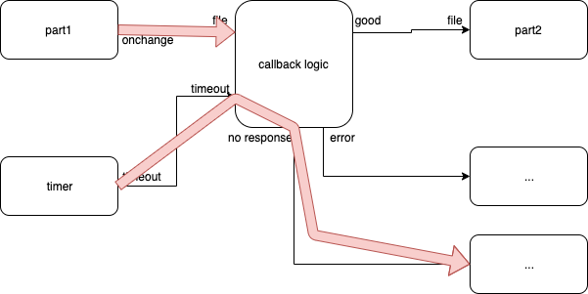
Fig. <$n:figure:TimeoutPath> Timeout Path

The red arrows show the control flow when things go horribly wrong, e.g. the FileReader can't read the file due to a server being down (or a break in the routing to the server, or, …).

